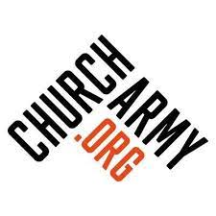

Env y Suffolk


Part of Env y National

Envoy is a free evangelism coaching community provided by Church Army for anybody aged 18+ who wants to make evangelism their way of life. Envoy is designed to fit into your life – whatever it looks like – and will equip you to live missionally wherever you are.
If you’d like to meet a member of the Envoy team, hear stories from previous participants or have an opportunity to ask questions, we are hosting one hour taster sessions. To book a place, please visit: www.envoy.website/what-is-envoy.

For more information about Envoy in Suffolk contact: Gail. Southgate@churcharmy.org.

‘

Envoy
Building small communities which are:
- expectant: that God is already at work and inviting us to join Him
- mutually accountable in discernment of God’s mission in each other’s context and in faithfully stepping into His call to join Him

Envoy
Small groups:
who build community in their time together
who speak and pray into each other’s context
who encourage each other and release God’s value
who desire for each other that sharing Jesus becomes real
who celebrate and share as each one begins to step out in faith

Envoy
Excellent, accessible half hour teaching podcasts to listen to ahead of gathering
Meeting in small communities during block program time
Meeting online and / or face to face
All groups facilitated by experienced Envoy peers
Ideal for Lightwave groups but open to everyone recommended by their local Church Leader

Envoy


A space where we are not told how or what, but instead where a door unlocks to how God wants to work uniquely through each one of us.

